Moffat Bay Lodge
Module 7 Functional Test Plan
To complete the test case plan, fill out the information for Project, Course, Description and Date in the header below.
Project: | Moffat Bay Lodge
Course: | CSD 460
Description: | About Us and Reservation Summary page and backend functional testing
Date: | 2026/09/12

TABLE OF CONTENTS
1. About Page Loads with Merged Contact Section
2. Contact API Inserts a New Message into the Database
3. Reservation Summary Information Transfers Correctly
4. Confirm Reservation from the Summary Page

Developer documentation: include a test description, objective, developer name, date tested, and only Pass or Fail for each developer result. Peer QA documentation: use a different tester name, record the actual test date, enter only Pass or Fail for every step, and include a screenshot thumbnail showing the result of every step. Add 2–3 substantive sentences of QA comments for each test.

Test 1: About Page Loads with Merged Contact Section
Test 1 | About Page Loads with Merged Contact Section
 | Test Objective: Verify that the About page loads successfully, contains the merged contact section and inquiry form, uses about.js, and has no dead link to the removed contact page. | Developer: Brayan Covarrubias  Date tested: 2026/09/12 | Peer tester: Tiffany Davidson  Date tested: 2026/09/13
Step | Action | Expected results | Developer pass/fail | Tester pass/fail + Screenshot
1 | Start MySQL in XAMPP, run `python src/api/startup_api.py`, and open http://127.0.0.1:8000/about.html. | The About page returns successfully and displays with no broken page elements. | Pass | Pass  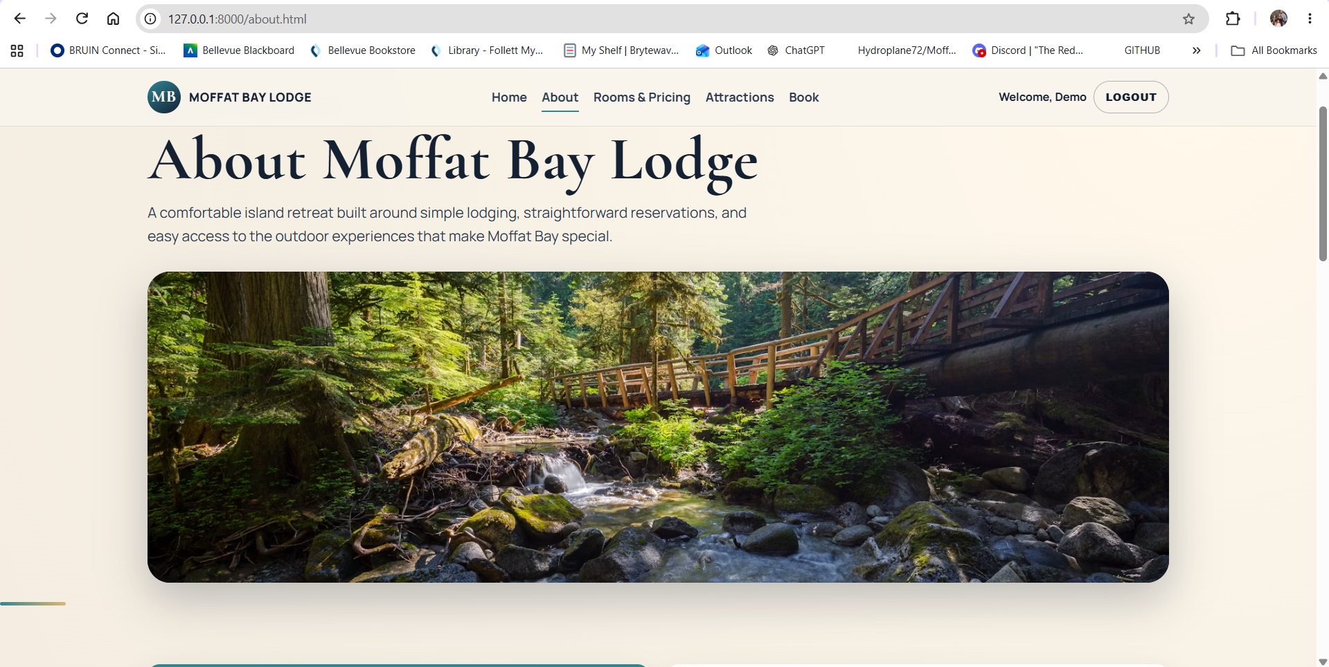
2 | Scroll to the “Contact Moffat Bay Lodge” section. | The contact section displays the Full Name, Email, Subject, Message, and Send Message controls. | Pass | Pass  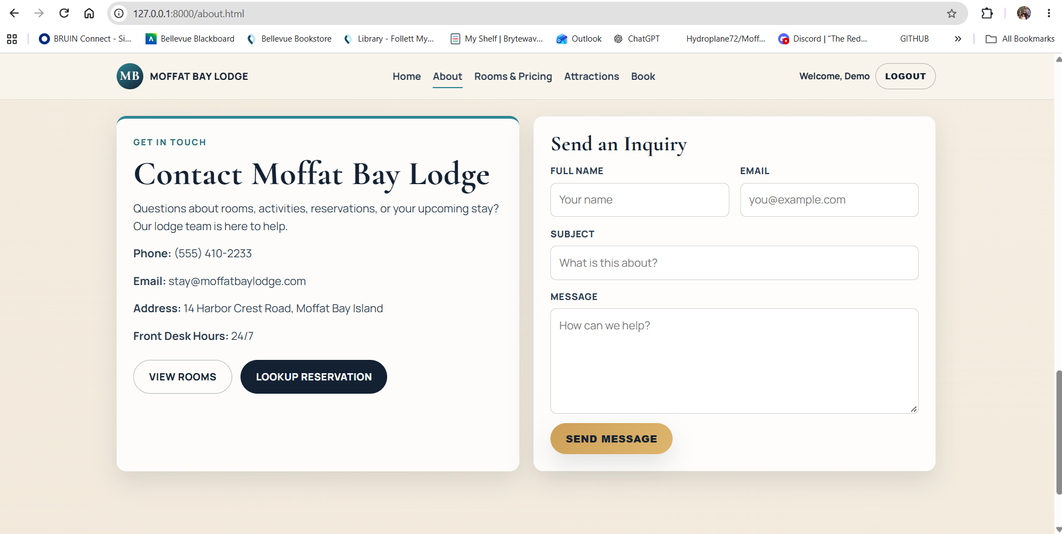
3 | Open DevTools Elements or View Page Source and locate the contact section. | The page contains id="contact", id="contact-form", and the production script assets/js/about.js. | Pass | Pass  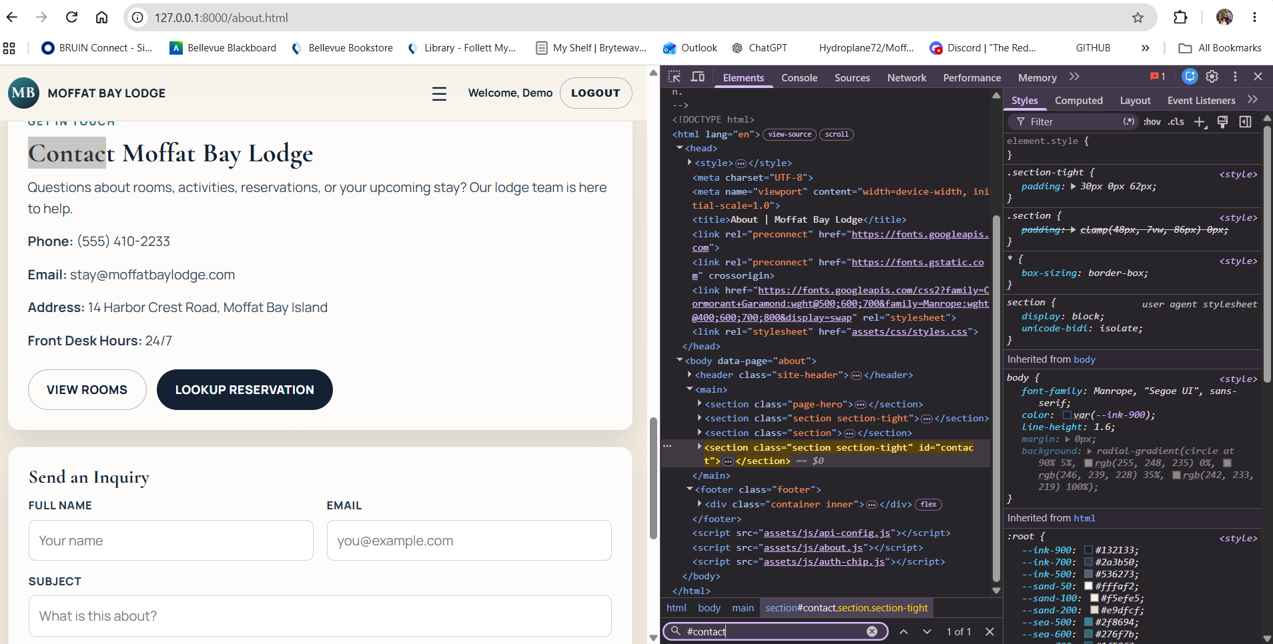
4 | Check the main navigation and footer links. | There is no link to contact.html and no dead Contact-page navigation remains. | Pass | Pass  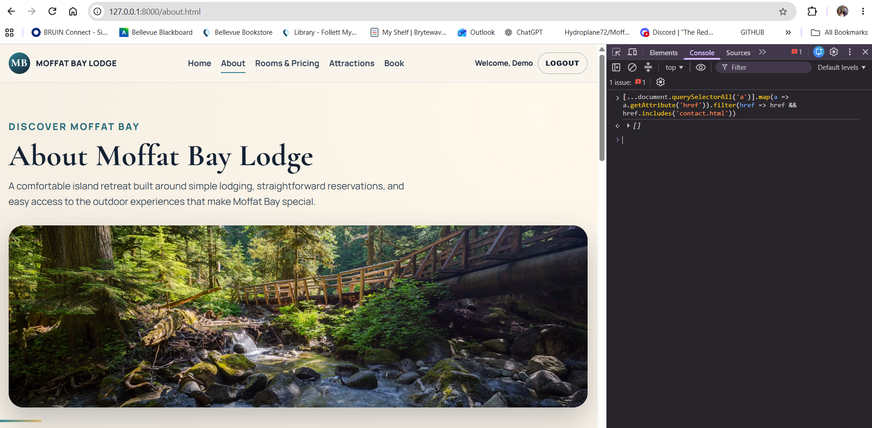
Comments | The About Us page loaded correctly and contained the integrated contact section, contact form, and production about.js script. The navigation and footer were also reviewed, and no dead links to the old contact.html page remained. No correction was needed because the contact functionality was properly integrated into the About Us page.

Test 2: Contact API Inserts a New Message into the Database
Test 2 | Contact API Inserts a New Message into the Database
 | Test Objective: Verify that the About page contact form posts to the backend and stores a new inquiry in ContactMessages. | Developer: Brayan Covarrubias  Date tested: 2026/09/12 | Peer tester: Tiffany Davidson  Date tested: <yyyy/mm/dd>
Step | Action | Expected results | Developer pass/fail | Tester pass/fail + Screenshot
1 | Open the About page contact section and enter a unique QA message, such as Tiffany QA / tiffany.qa@example.com / Module 7 QA Test / This is a Module 7 QA test message. | All required contact fields accept the test values. | Pass | Pass  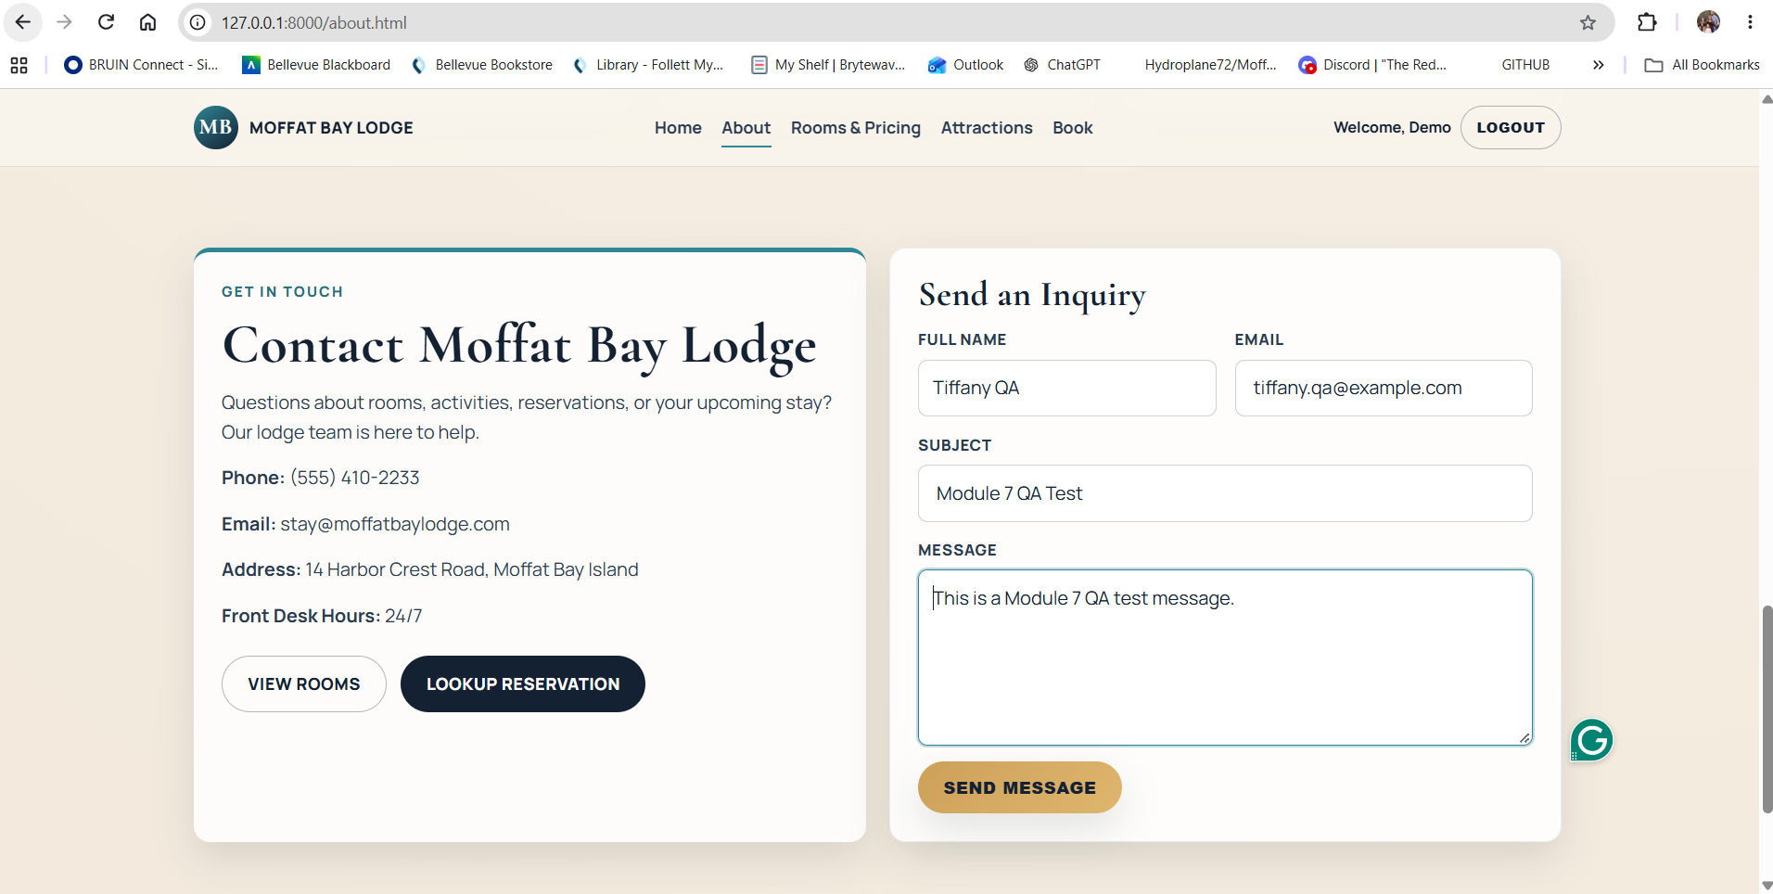
2 | Click “Send Message.” | The page displays “Thanks! Your message has been sent.” in the success message area. | Pass | Pass  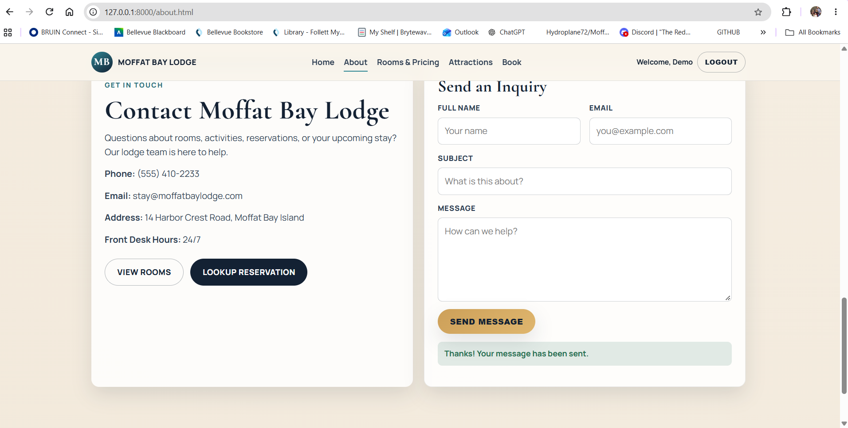
3 | In MySQL, run `SELECT * FROM ContactMessages ORDER BY message_id DESC LIMIT 1;`. | The newest ContactMessages row contains the QA name, email, subject, and message that were submitted. | Pass | Pass  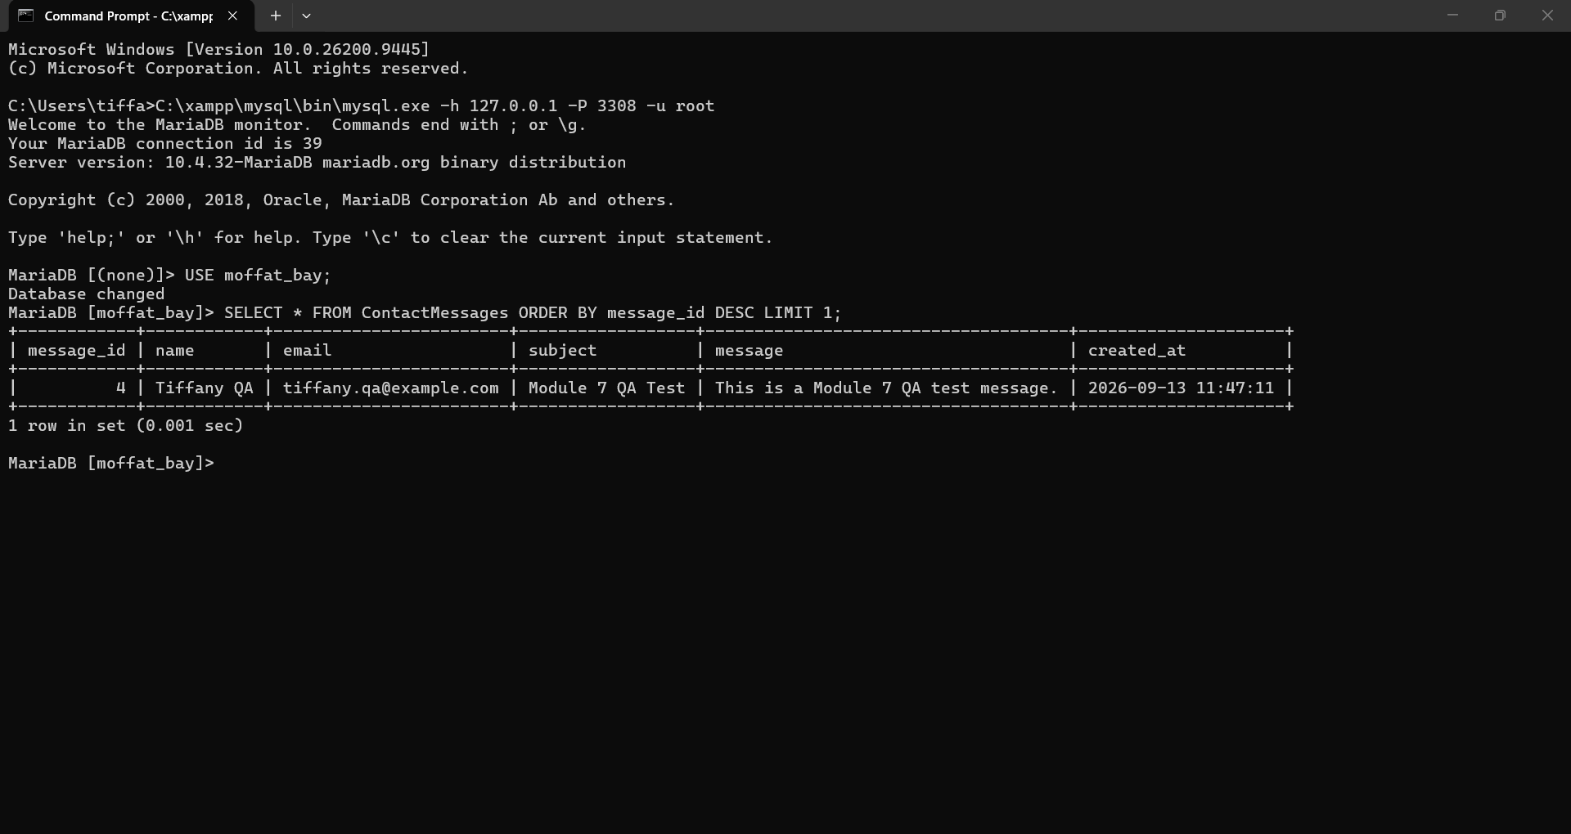
4 | Run `python -m pytest src/api/tests/test_about_api.py::test_contact_api_inserts_new_message_into_database -v`. | The targeted FT-AB-02 automated test finishes with PASSED. | Pass | Pass  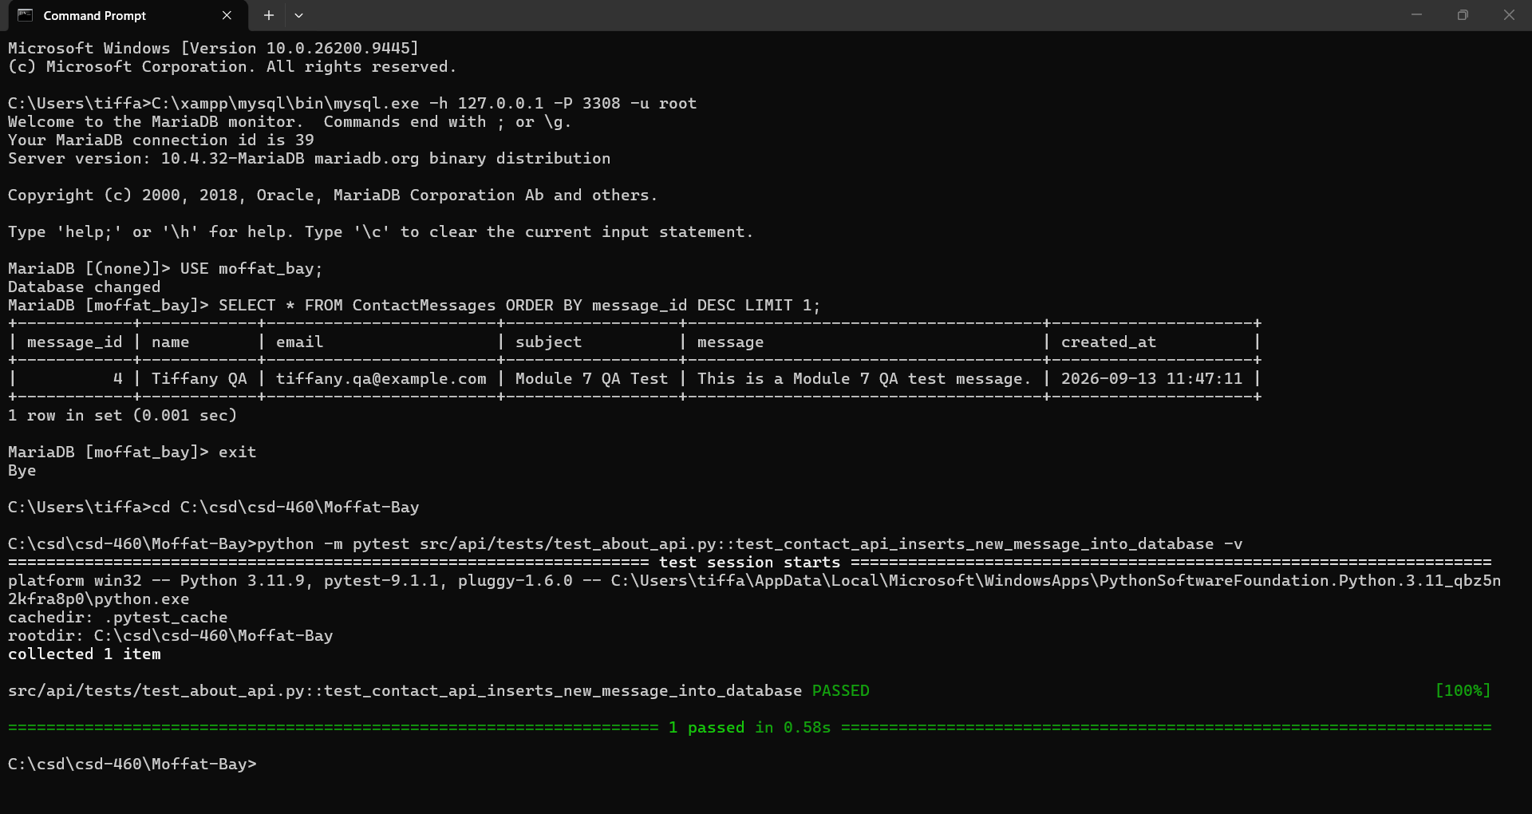
5 | Optionally remove only the manual QA message after screenshots are captured. | The QA evidence remains documented, while the local test database can be returned to a clean state. | Pass | Pass  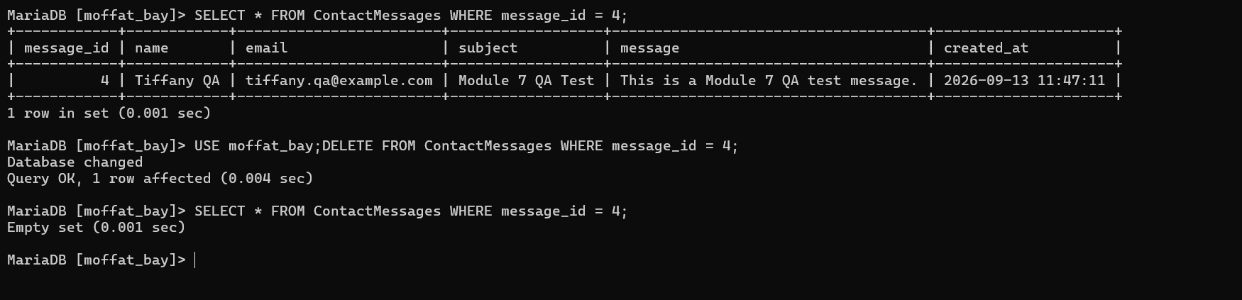
Comments | The contact form accepted the required information and submitted the message successfully through the backend. The submitted data was processed as expected and the page provided the correct response to the user. No functional issues were found during testing, so no correction was needed.

Test 3: Reservation Summary Information Transfers Correctly
Test 3 | Reservation Summary Information Transfers Correctly
 | Test Objective: Verify that the Reservation Summary page displays the same dates, guests, selected room, number of nights, and calculated total entered on the Reservation page. | Developer: Rashai Robertson  Date tested: 2026/09/10 | Peer tester: Tiffany Davidson  Date tested: <yyyy/mm/dd>
Step | Action | Expected results | Developer pass/fail | Tester pass/fail + Screenshot
1 | Log in with the demo account and open reservation.html. | The logged-in reservation form is visible and ready for input. | Pass | Pass  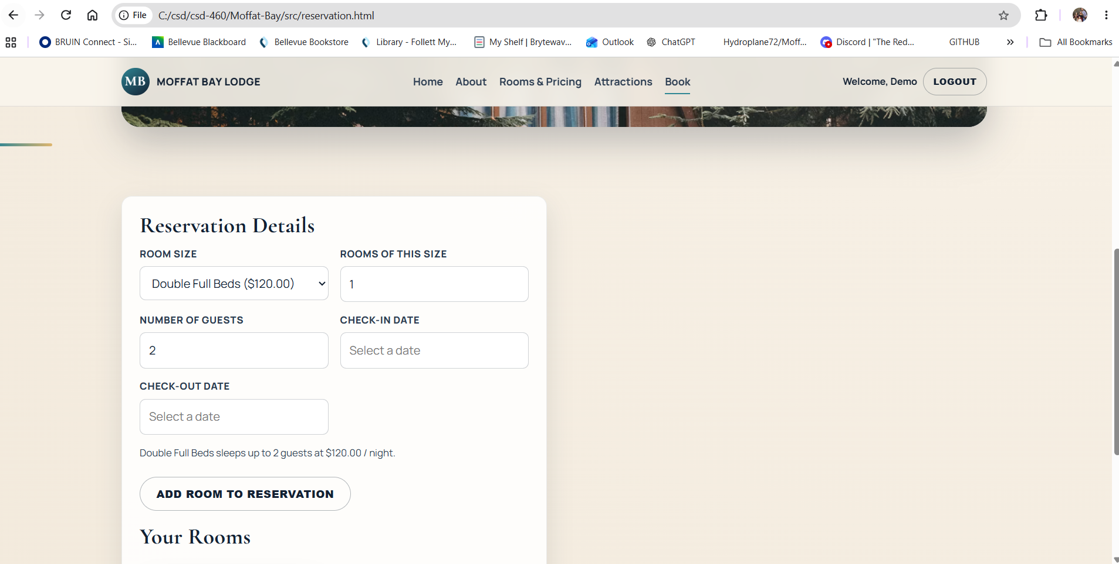
2 | Enter 2 guests, select 1 King room, and choose a valid two-night future stay. | All reservation inputs are accepted. | Pass | Pass  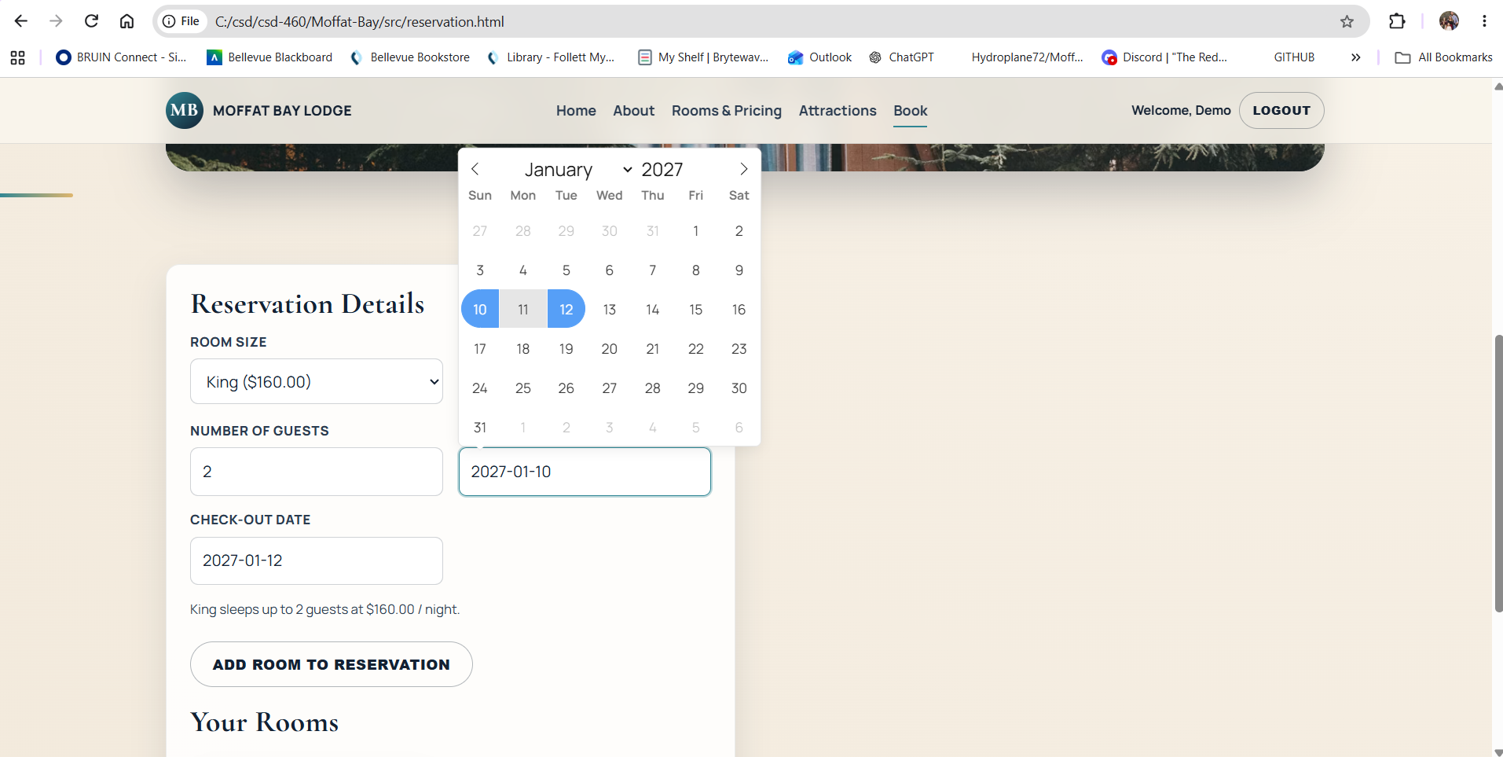
3 | Click “Add Room to Reservation,” then click “Continue to Summary.” | The King room is added as available and reservation-summary.html loads successfully. | Pass | Pass  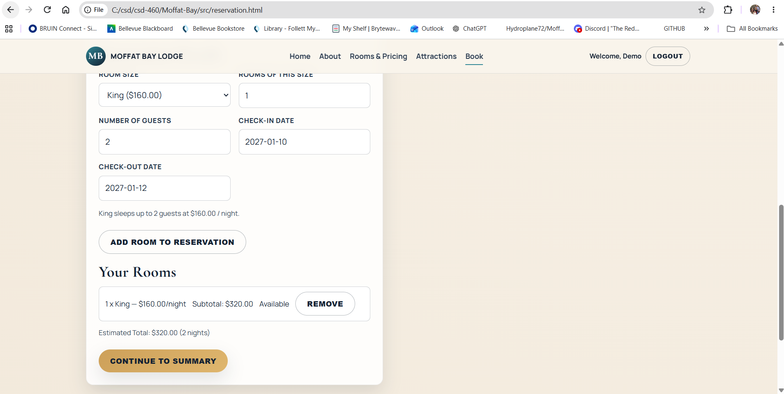
4 | Compare the summary details with the values entered on the Reservation page. | The check-in, check-out, guest count, King room selection, quantity, and number of nights all match. | Pass | Pass  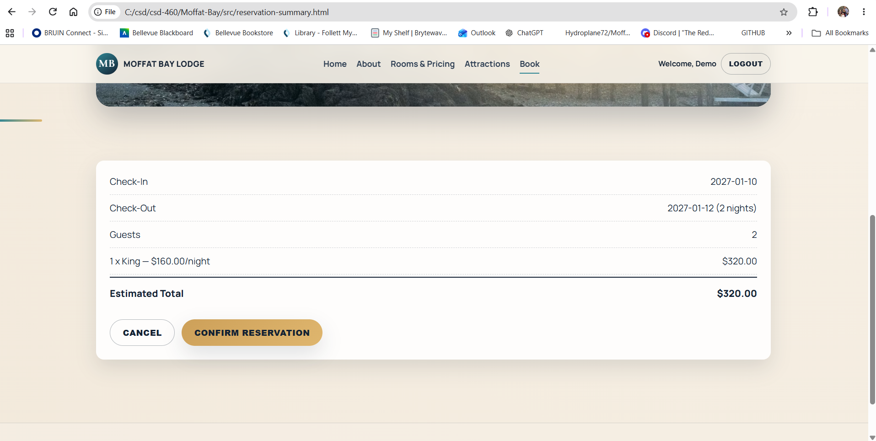
5 | Review the Estimated Total. | The total equals the selected room’s nightly rate multiplied by the number of nights and room quantity. | Pass | Pass
Comments | The Reservation Summary page displayed the reservation information entered during the previous steps, including the selected dates, guest information, and room details. The data transferred correctly to the summary page and remained consistent with the selections made on the reservation page. No correction was needed because the summary functionality worked as expected.
Test 4: Confirm Reservation from the Summary Page
Test 4 | Confirm Reservation from the Summary Page
 | Test Objective: Verify that the Confirm Reservation button completes a valid reservation, returns a confirmation number, and stores linked reservation data in MySQL. | Developer: Rashai Robertson  Date tested: 2026/09/10 | Peer tester: Tiffany Davidson  Date tested: <yyyy/mm/dd>
Step | Action | Expected results | Developer pass/fail | Tester pass/fail + Screenshot
1 | Complete a valid reservation and continue to reservation-summary.html. | The Reservation Summary page displays the selected reservation and the Confirm Reservation button is enabled. | Pass | Pass  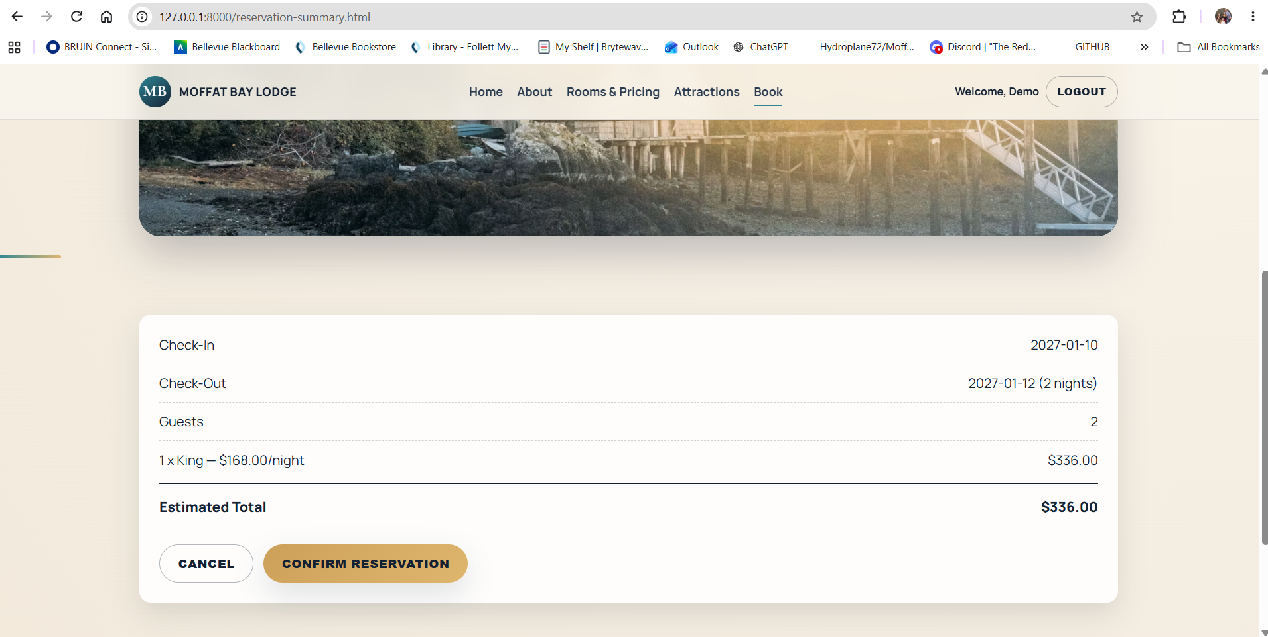
2 | Review the displayed reservation details before confirming. | The room, dates, guests, nights, and estimated total are correct. | Pass | Pass  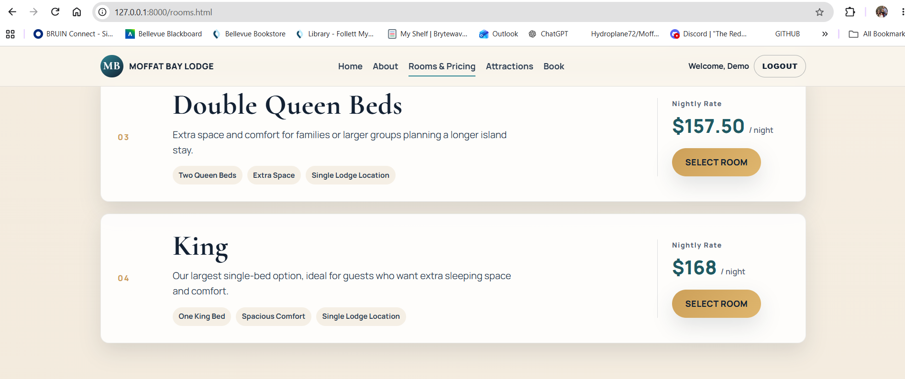
3 | Click “Confirm Reservation.” | The page sends the reservation to the backend for creation. | Pass | Pass  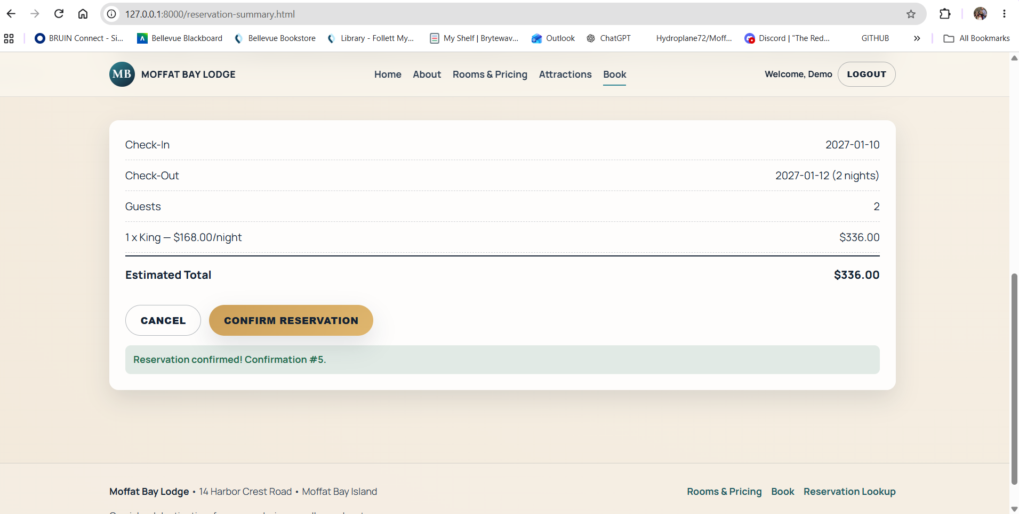
4 | Review the confirmation message. | A success message displays “Reservation confirmed!” followed by a numeric confirmation number. | Pass | Pass
5 | In MySQL, run `SELECT * FROM Reservations ORDER BY reservation_id DESC LIMIT 1;`. | The newest Reservations row contains the expected customer, dates, guest count, total, and confirmed status. | Pass | Pass  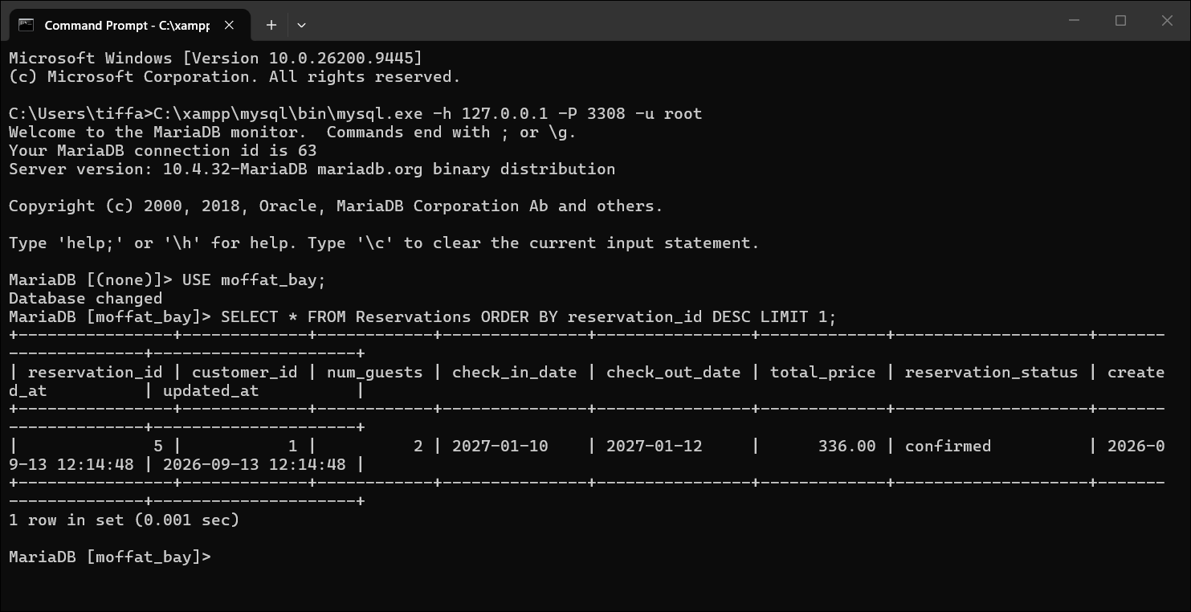
6 | Using that reservation_id, query `SELECT * FROM ReservationRooms WHERE reservation_id = <id>;`. | At least one linked ReservationRooms row exists for the confirmed reservation. | Pass | Pass  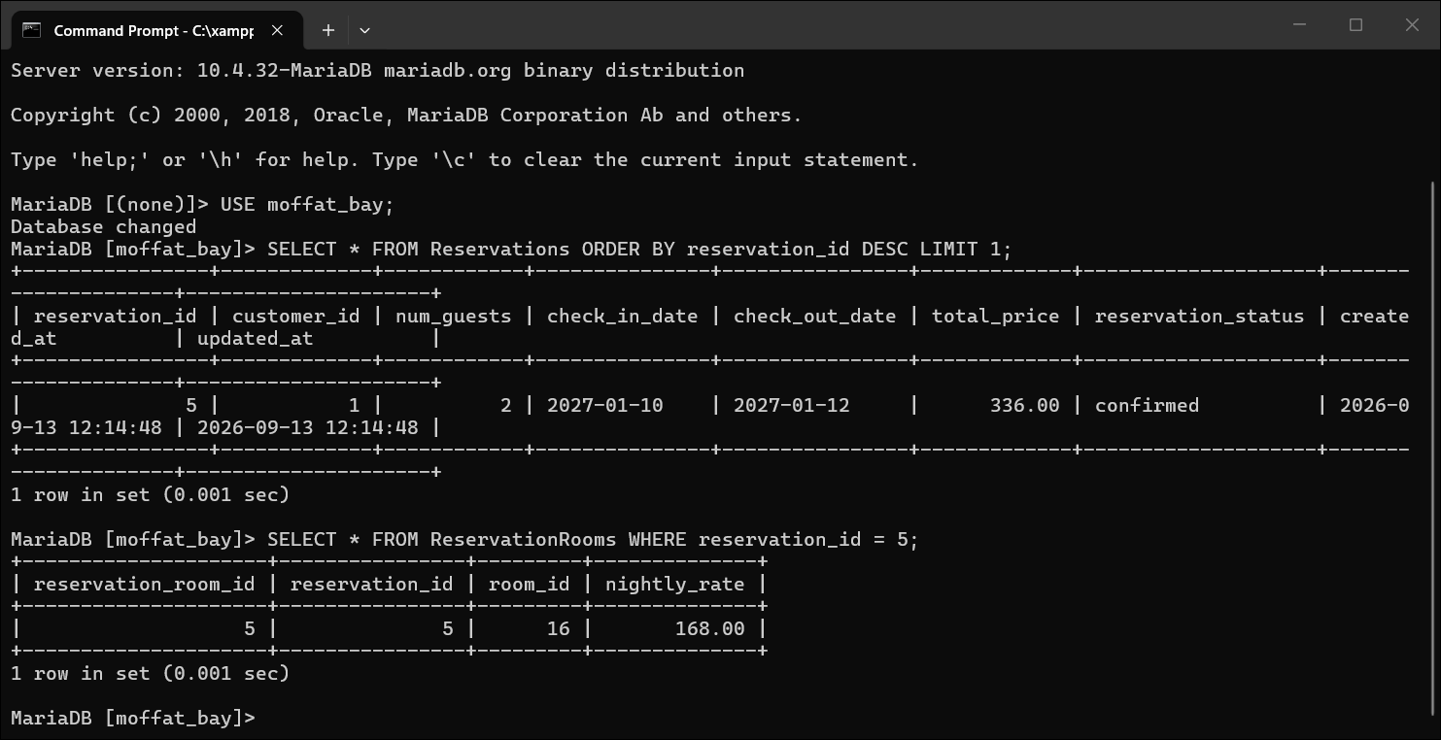
7 | Review the summary page controls after confirmation. | The Confirm Reservation and Cancel controls are disabled, preventing the same booking from being submitted twice. | Pass | Pass  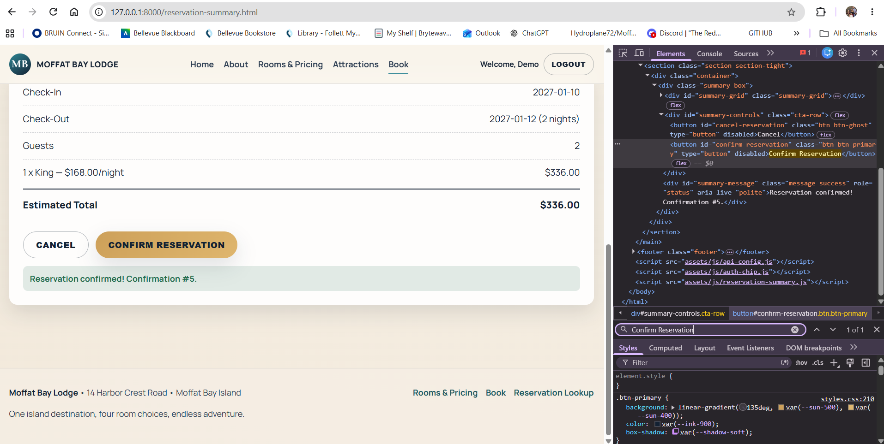
Comments | The reservation was successfully completed from the summary page and the confirmation information displayed correctly. The final reservation details matched the information reviewed on the summary page and were stored successfully by the backend. No additional correction was needed after testing confirmed the reservation process worked correctly.

